Adding Ancillary Services – Adding Seats, Meals & Baggage

Ancillary Services – Adding Seats, Meals & Baggage on Portal (While making booking online)

- Login to travelboutiqueonline.com on portal
- Search the flight you want to book

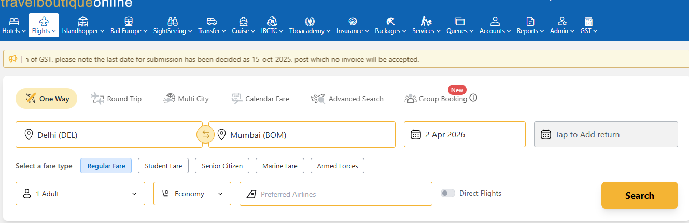

- Select the flight and click on ‘Book Now’
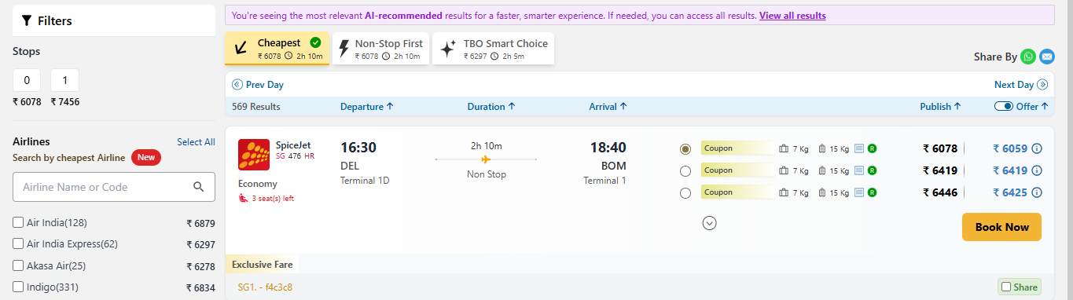

- Fill the required details
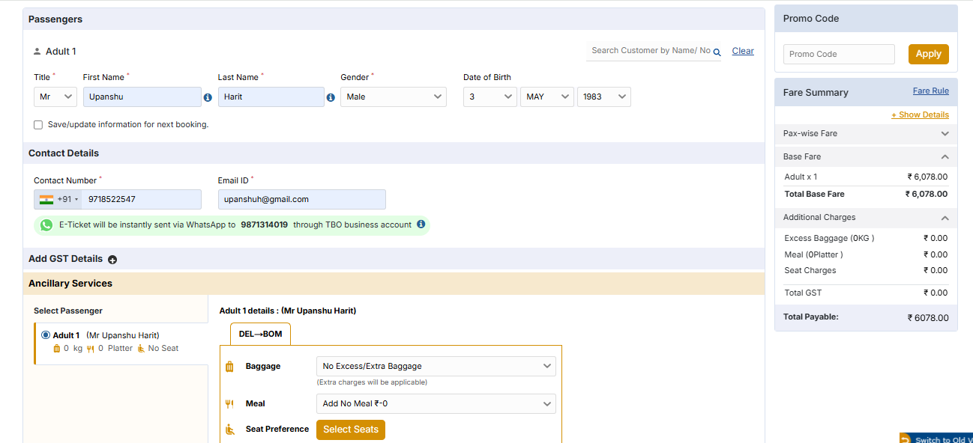
- In the Ancillary option, you will see Baggage, Meal & Seat Preference
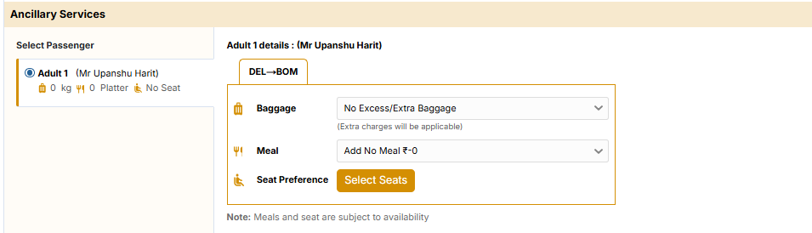
For Baggage -:

- Click on Baggage and select the baggage option from the list (this will also show the price)
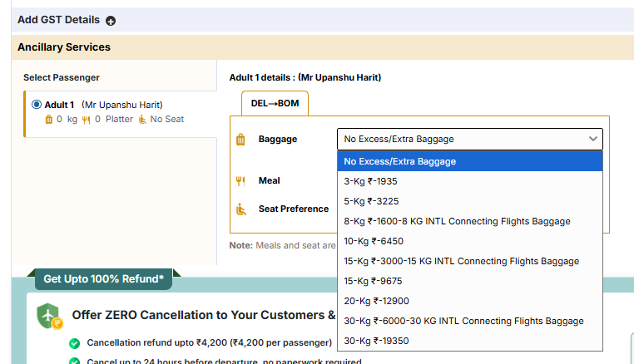

- Click on ‘Proceed’ Booking to confirm the selection and booking
For Meal -:
- Select the Meal from the list shown (This will also show price along with meal)
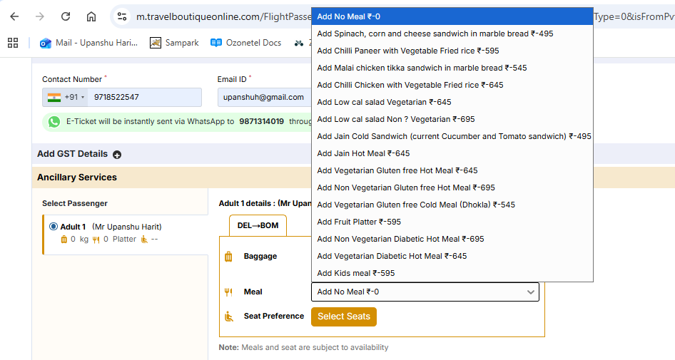

- Click on Proceed Booking to confirm selection along with the meal
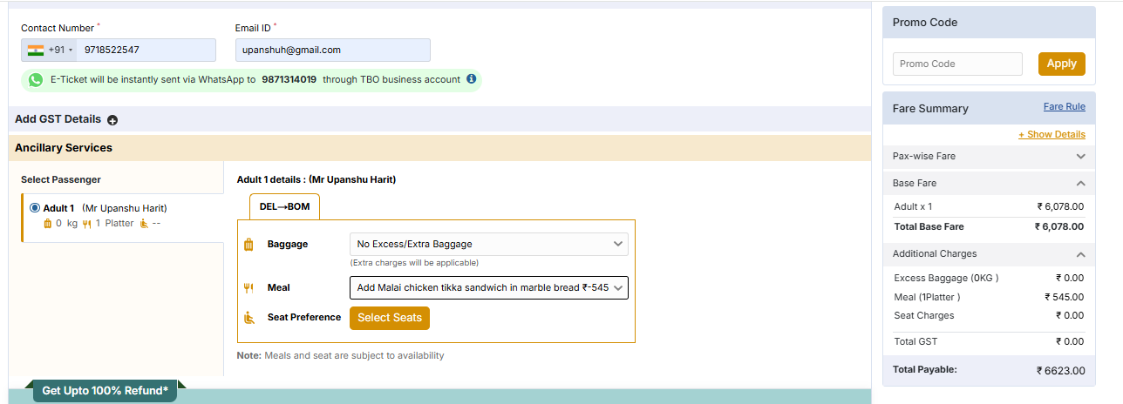

For Seat -:
- From Ancillary Services and seat preference, click on ‘Select Seat’
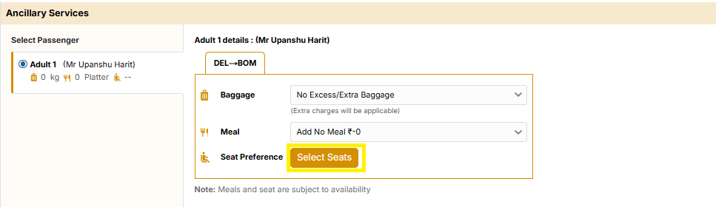

- This will open the Aircraft seat plan, select as per the preference of travel agent (place curser over the seat and it will also show prices)
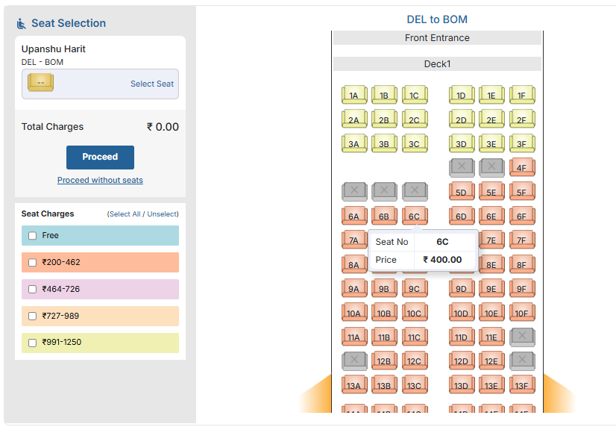

- Click on Proceed
- Click on Proceed Booking to confirm selection along with the meal
